DR KV SUBBA REDDY INSTITUTE OF TECHNOLOGY

(AFFILIATED BY JNTUA,ANANTAPUR,APPROVED BY AICTE)

KURNOOL-518218

DEPARTMENT OF ELECTRONICS AND COMMUNICATION ENGINERRING

## IOT VIRTUAL DOCTOR ROBOT

UNDER THE GUIDANCE OF HEAD OF THE DEPATMENT REPRASENTED BY Dr.M.V.SRUTHI T.VIJAY KUMAR E.BINDUPRIYA(19FH1A0461)

M.Tech.ph.D M.Tech.ph.D S.ASHA (19FH1A0473) ASSOCIATE PROFESSOR M.HAREESHA (19FH1A0467)

K.MANJU (20FH5A0405) S.TALAHA (19FH1A0494)

CONTENTS:

* ABSTRACT
* INTRODUCTION
* OBJECTIVE
* IMPLIMENTATION
* BLOCK DIAGRAM
* DESIGN OF HARDWARE
* DESIGN OF SOFTWARE
* ADVANTAGES&DISADVANTAGES
* APPLICATIONS
* CONCLUSION
* REFERENCES

# ABSTRACT:

Doctors are usually needed to work at every hospital and emergency centre every now and then. But it is not feasible for every doctor to be available at every place at desired time. The problem with video calling is that video calls need to be done from a PC or laptop on a desk. This limits the doctors capacity to view patient or around operation theatre at will or even move through hospital rooms as needed.

To help solve this issue we here develop a virtual doctor robot that allows a doctor to virtually move around at a remote location at will and even talk to people at remote location as desired.

The system makes use of a robotic vehicle with 4 wheel drive for easy navigation. The robot also includes a controller box for circuitry and a mounting to hold a mobile phone or tablet. The mobile or tablet is used to hold live video calls.

The doctor can use an IOT based panel to control the robot. Also the root has other

functions including battery status alert to remind of battery charging on time.

Here adding one more sensor i.e., temperature sensor for know the temperature of patient. If any temperature increases, doctor will give the suggestions and patient will take the medicine from medicine box.

# INTRODUCTION:

### The current scenario point out that the role of using robotic technology and internet of things for the out break of covid19 is very crucial and essential in hospital and societal sectors.

* The doctor can used an iot based panel to control the robot.

### The control commands sent online are received by the robot controller.

* The robot controller operates over WIFI internet
* The received commands are received in real time and the robot motors are operated to achive the desired movement commands

# OBJECTIVE:

* + The objective of this project is to provide effective medical care to the rural

poor

* + Especially doctors and nurses to help them
  + People in village and remote areas do not stand a change to get treated by a medical expert who lives in cities
  + To provide medical services to the patients affected by covid-19

# IMPLEMENTATION:

* Sometimes, doctors are obliged to work at every hospital and urgent care facility

simultaneously.

* However, it is impossible for every doctor to be available at all times or in all locations. With video business, it's necessary to do video calls from a laptop or laptop computer on a table.
* To assist in resolving this problem, we have created a virtual doctor automaton that enables a physician to virtually roam around in a distant country and even sit down with patients there as needed.
* -The ability to be anywhere, at any time
* - The ability to easily move among patients and operating rooms;
* -The capacity to see medical reports remotely through video chats;
* - The ability to walk about in many rooms at once.

# BLOCK DIAGRAM:

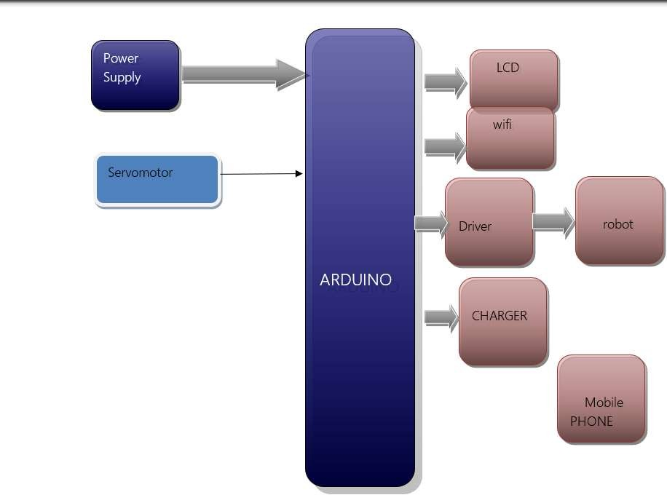

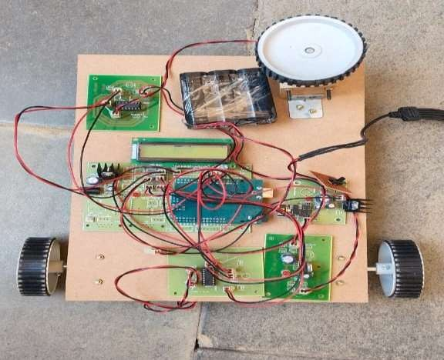

## DESIGN OF HARDWARE :

ARDUINO

The most common version of Arduino is the Arduino Uno. This board is what most people are talking about when they refer to an Arduino. The Uno is one of the more popular boards in the Arduino family and a great choice for beginners. There are different revisions of Arduino Uno, below detail is the most recent revision (Rev3 or R3).

The Arduino Uno is a microcontroller board based on the ATmega328. It has 14 digital input/output pins (of which 6 can be used as PWM outputs), 6 analog inputs, a 16 MHz ceramic resonator, a USB connection, a power jack, an ICSP header, and a reset button. It contains everything needed to support the microcontroller; simply connect it to a computer with a USB cable or power it with an AC-to-DC adapter or battery to get started.

Microcontroller : ATmega328

Operating Voltage : 5V

Input Voltage (recommended) : 7-12V

Input Voltage (limits) : 6-20V

Digital I/O Pins : 14 (of which 6 provide PWM output)

Analog Input Pins : 6

DC Current per I/O Pin : 40 mA

DC Current for 3.3V Pin : 50 mA

Flash Memory : 32 KB (ATmega328) of which 0.5 KB u

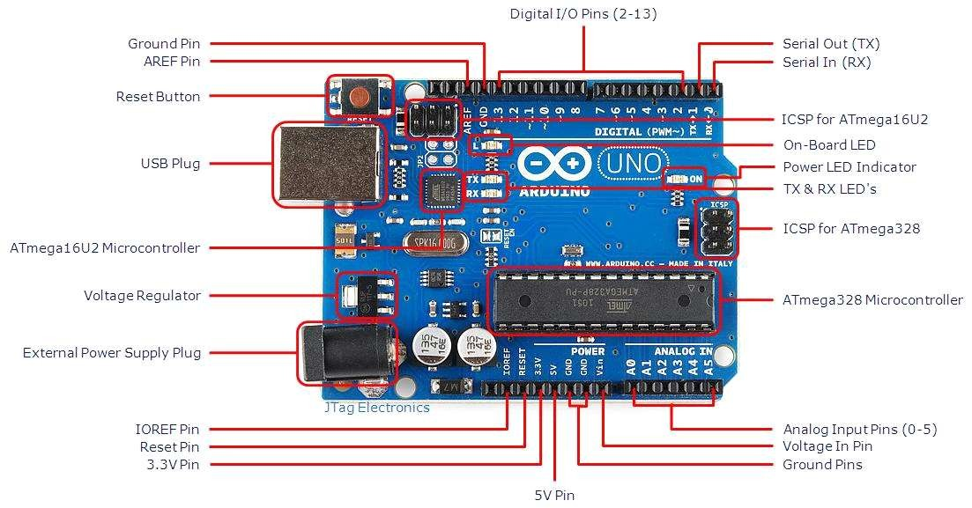

fig

POWER SUPPLY

The power supplies are designed to convert high voltage AC mains electricity to a suitable low voltage supply for electronic circuits and other devices. A power supply can by broken down into a series of blocks, each of which performs a particular function. A d.c power supply which maintains the output voltage constant irrespective of a.c mains fluctuations or load variations is known as “Regulated D.C Power Supply”.

LCD

* + A model described here is for its low price and great possibilities

most frequently used in practice

* + It is based on the HD44780 microcontroller (Hitachi) and can

display messages in two lines with 16 characters each.

* + It displays all the alphabets, Greek letters, punctuation marks,

mathematical symbols etc.

* + In addition, it is possible to display symbols that user makes up on its own.
  + Automatic shifting message on display (shift left and right), appearance of the pointer, backlight etc. are considered as useful characteristics

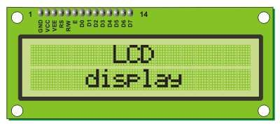

LCD

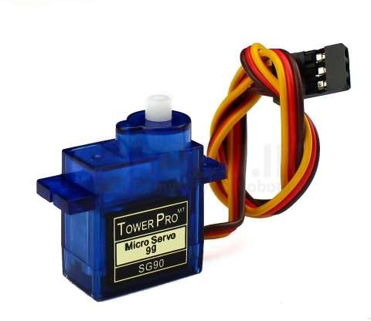SERVO MOTOR

* A servo motor is a type of motor that can rotate with great precision.
* Normally this type of motor consists of control circuit that provides feedback on the current position of the motor shaft,
* This feedback allows the servo motors to rotate with grate precision
* If we want to rotate an object at some specific angles or distance, then we use the servo motor

ESP-8266

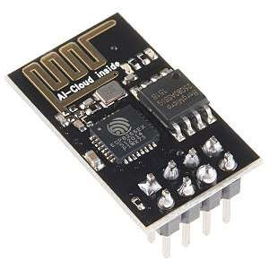

ESP-8266

* The ESP-8266 is a low[-cost Wi-Fi microchip withWfiu-Flli](https://en.wikipedia.org/wiki/TCP/IP_stack)

[TCP/IP](https://en.wikipedia.org/wiki/TCP/IP_stack)

[TCP/IP](https://en.wikipedia.org/wiki/TCP/IP_stack)

stack and microcontroller[s](https://en.wikipedia.org/wiki/TCP/IP_stack)c[ta](https://en.wikipedia.org/wiki/TCP/IP_stack)a[c](https://en.wikipedia.org/wiki/TCP/IP_stack)p[k](https://en.wikipedia.org/wiki/TCP/IP_stack)ability

[microcontroller](https://en.wikipedia.org/wiki/Microcontroller)

* This small module allows microcontrollers to connect to a Wi-Fi network and make simple TCP/IP connections using Hayes-style commands. However, at the time there was almost no English-language documentation on the chip and the commands it accepted.
* The very low price and the fact that there were very few external components on the module which suggested that it could eventually be very inexpensive in volume, attracted many hackers to explore the module, chip, and the software on it, as well as to translate the Chinese documentation.
* The **ESP8285** is an ESP8266 with 1 MiB of built-in flash, allowing for single-chip devices capable of connecting to Wi-Fi.

BATTERY

* + 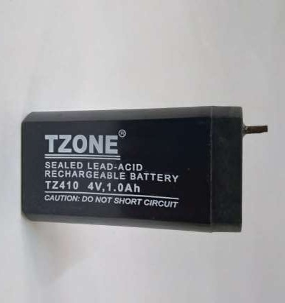A **Lithium-ion** or **Li-ion battery** is a type of rechargeable battery which uses the reversible reduction of lithium ions to store energy.
  + It is the predominant battery type used in portable consumer

electronics and electric vehicles.

* + It also sees significant use for grid-scale energy storage and military

and aerospace applications.

* + Compared to other rechargeable battery technologies, Li-ion batteries have high energy densities, low self-discharge, and no memory effect (although a small memory effect reported in LEP cells has been traced to poorly made cells).

BATTERY

## DESIGN OF SOFTWARE

ARDUINO IDE SOFTWARE

This is free software (evaluation version) which solves many of the pain points for an embedded system developer. This software is an Integrated Development Environment(IDE), which integrated text editor to write program, a compiler and it will convert your source code into HEX file. Here is simple guide to start working with Arduino IDE Vision which can be used for:

* Writing programs in Arduino IDE
* Compiling and assembling programs
* Debugging programs

WORKING PRINCIPLE

* + The system only works when a person is in front of he device.
  + The ultrasonic distance-measurement sensor (HC SR-04) sense the change in

the distance around the device.

* + The device then asks for the details programmed on the screen .for example it ask the patient to open their mouth and their eyes, and the takes photos using the camera module, saving the images locally.
  + The device also requests the patients ID.
  + After all the data is documented, it e-mails the registered doctor with the

attached the images, using the “multi part content type “.

* + This type of the data that specifies that the e-mail contents media content.
  + This e-mail is sent using the smtp protocol. The physician download the e-mail using the standard , internet massage access protocol( IMAP).

## ADVANTAGES:

* + - Doctors are ability to be at anyplace anytime
    - Doctors cam move around in operation theatres
    - Doctors can move around the patient with ease
    - Doctors can see medical reports remotely via video calls
    - Doctors can move around in other rooms at will

## DISADVANTAGES:

* Requires battery charging
* Need to attach the tab or mobile phone

## APPLICATIONS:

* Hospitals &Clinics
* Emergency Centers

## CONCLUSION:

Because of severe attack of pandemic coronavirus across the globe, everyone has to get secured and to get awareness about the using of high end robotic technology and IoT enabled services at hospitals, shopping malls, public areas, quarantine centres, schools, colleges and many more once the lockdown or quarantine period lifts up.

This robot provides a whole lot of advantages for doctors:

* Doctors ability to be at anyplace anytime
* Doctors can move around in operation theatres
* Doctors can move around the patient with ease
* Doctors can move around in other rooms at will

## REFERENCES:

. https:/[/w](http://www.latimes.com/science/story/2020-04-11/overcoming-corona)w[w.latimes.com/science/story/2020-04-11/overcoming-corona](http://www.latimes.com/science/story/2020-04-11/overcoming-corona) virus-with-help-of- robots.

1. https:/ medical virology introduction by TV Rao, Md
2. Zimmer C.”A catalog for all the worlds viruses?”(retrieved 6 september 2013)
3. https:/lifescience.com – The deadliest viruses on Earth.
4. Zunt, Dominik.”who did actually invent the word robot and what does it mean?” The karelcapek

website.

1. An introduction to robotics, by Dr.Bob Williams.
2. Automation, Production Systems, and Computer-Integrated Manufacturing, Third Edition, by

Mikell P. Groover. ©2008 Pearson Education, Inc.,

1. Introduction to Industrial Robotics and Current Research for Industry 4.0, by Dr.-Ing. Dipl.-

Wirt.Ing. Tim Detert

1. https:/[/w](http://www.ida.gov.sg/~/media/Files/Infocomm%20Landscape/Techno)w[w.ida.gov.sg/~/media/Files/Infocomm%20Landscape/Techno](http://www.ida.gov.sg/~/media/Files/Infocomm%20Landscape/Techno) logy/Technology Roadmap/Internet OfThings.pdf
2. Dr. Ovidiu Vermesan SINTEF, Norway, Dr. Peter FriessEU, Belgium, “Internet of Things